A picture containing clipart

Description generated with very high confidence

Azure 103 Hands On - 1

Azure Certification Training

[**support@intellipaat.com**](mailto:support@intellipaat.com)

**+91-7022374614**

**US: 1-800-216-8930(Toll Free)**

**Azure 103 Hands On - 1**

**Manage Resource Groups in Azure**

**Problem Statement: Create a resource group and add resources in it.**

**Description: We will create a resource group for a dummy application (meaning, we will not be creating any application). So the resource group should logically consist of the resources that could be used in the creation of that application.**

**Step 1:** Go to portal.azure.com and sign into your Azure account. Azure dashboard page of your Azure portal will appear on the screen as shown below.

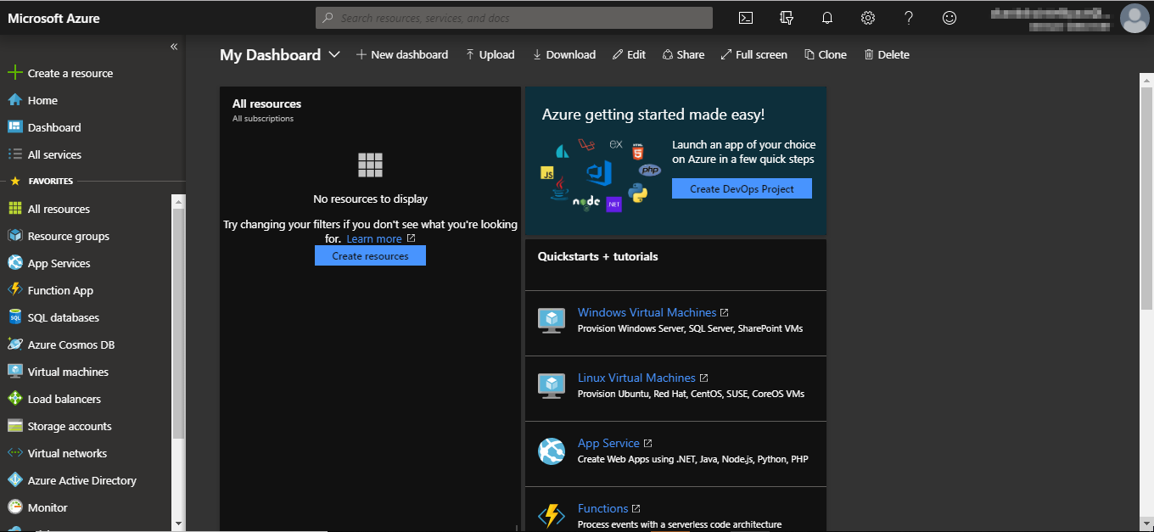

**Step 2:** Navigate to the **Resource groups** option on the left side menu as shown in the following image.

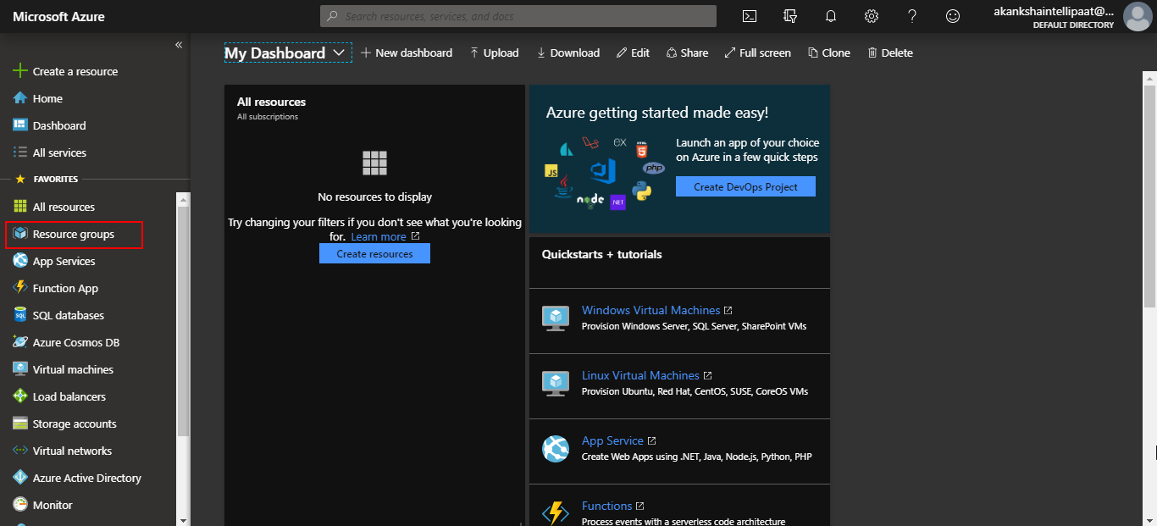

**Step 3:** Click on **Resource groups** option and you will be taken to the resource groups dashboard where you’ll see various options such as **add, edit column and more.** Click on add option.

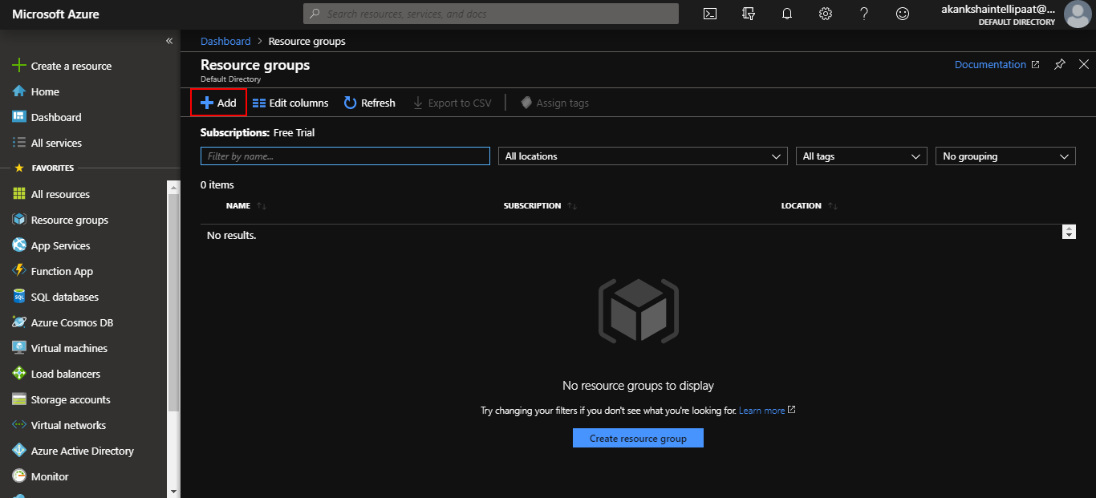

**Step 4:** Provide a name for your resource group in the respective field. You can keep the subscription as per your Azure subscription. And then click on Review & create.

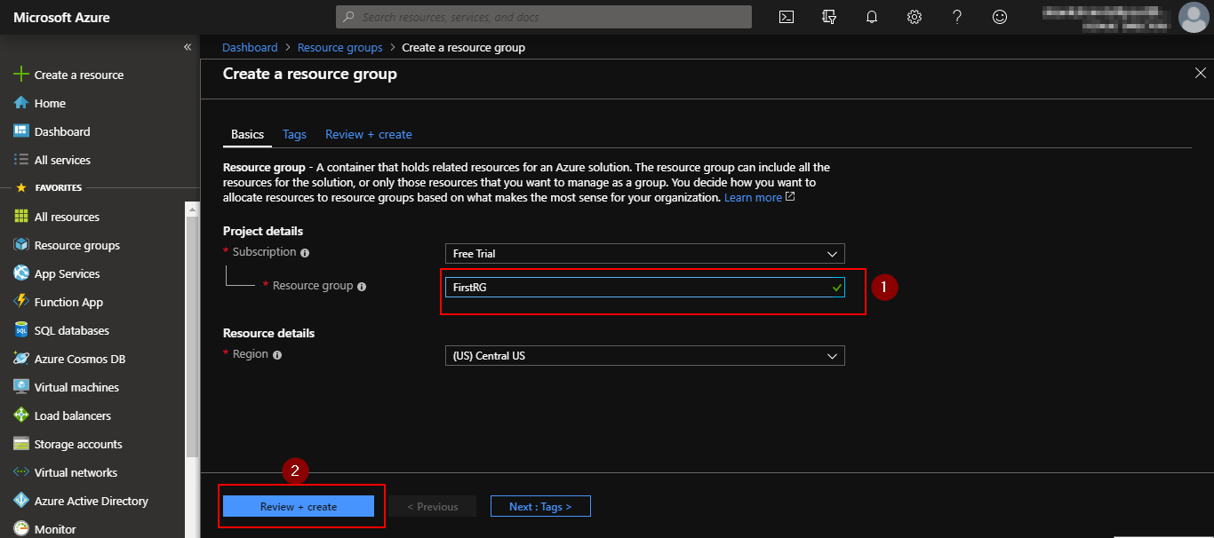

**Step 4:** You will be taken to the final page in creating a resource group. Check if the **“validation passed”** message is displayed as shown in the following screenshot, then click on **create.**

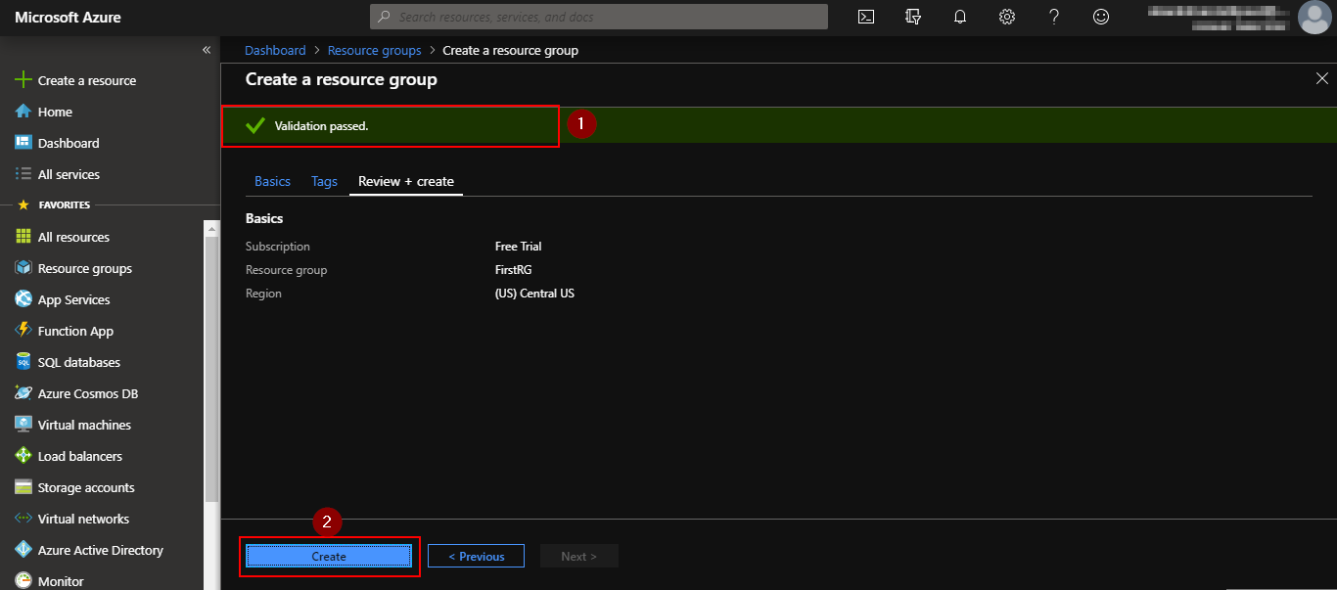

**Step 5:** You’ll get a notification saying that the resource group is created and you will be able to see your resource group listed in your resource group dashboard.

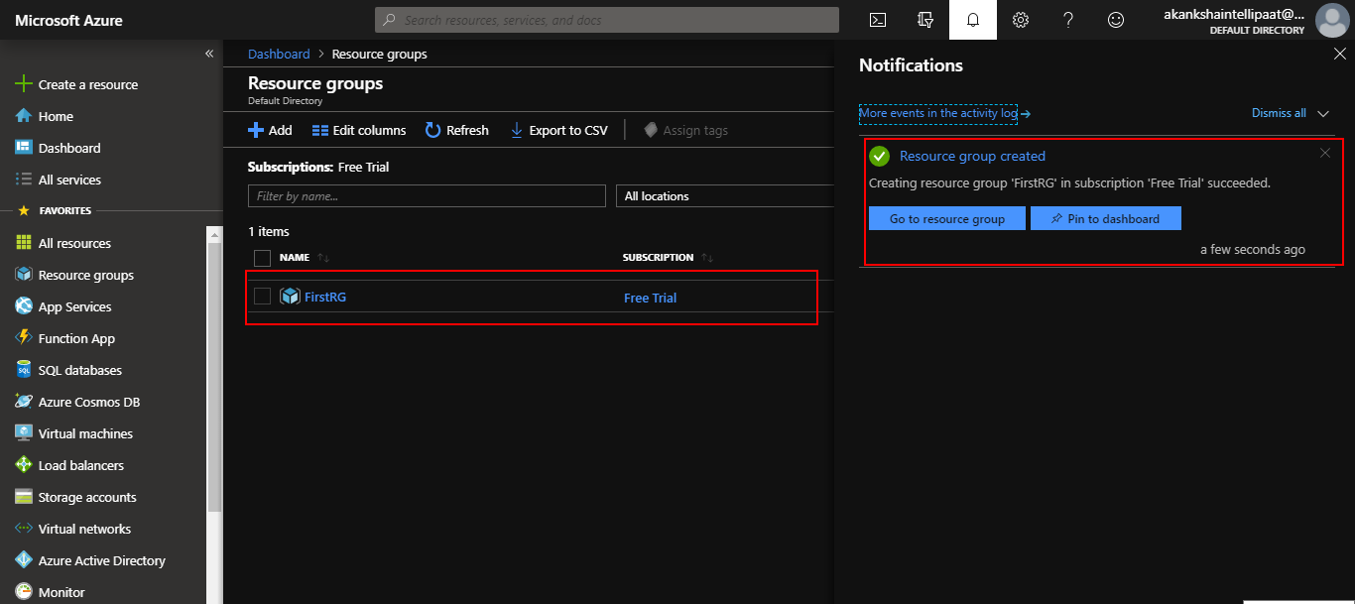

**Step 6:** Go back to the dashboard and select **App Services** option from the menu on the left side panel.

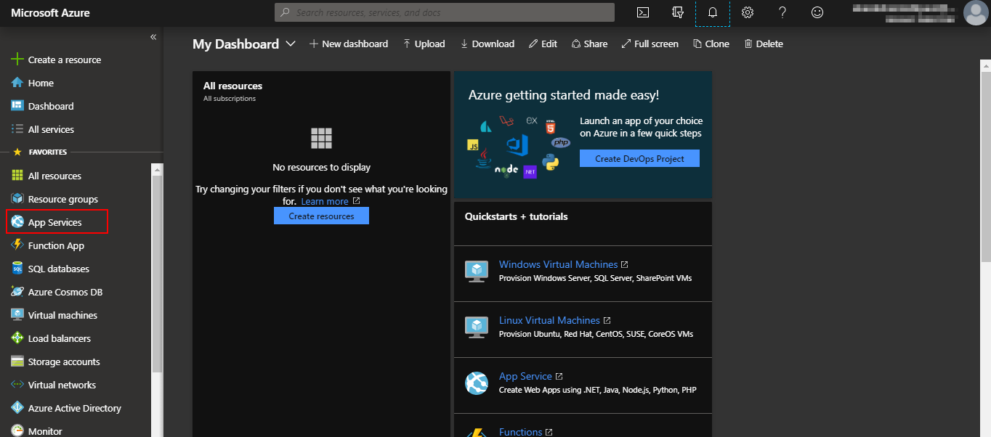

**Step 7:** When the following page appears, click on add option.

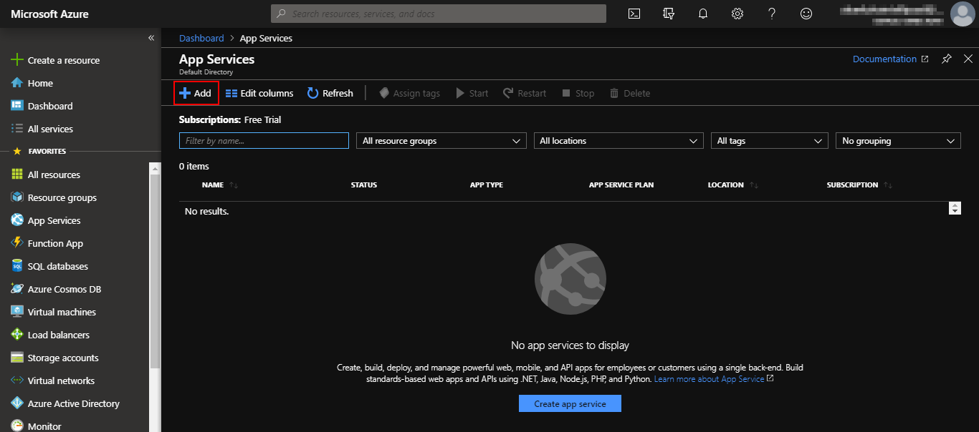

**Step 8:** Select the resource group that we just created in the resource group field and then provide the name of the resource, that is, the app service that we will choose. You can keep the subscription as per your Azure subscription.

**Note: The name for the resource should be unique.**

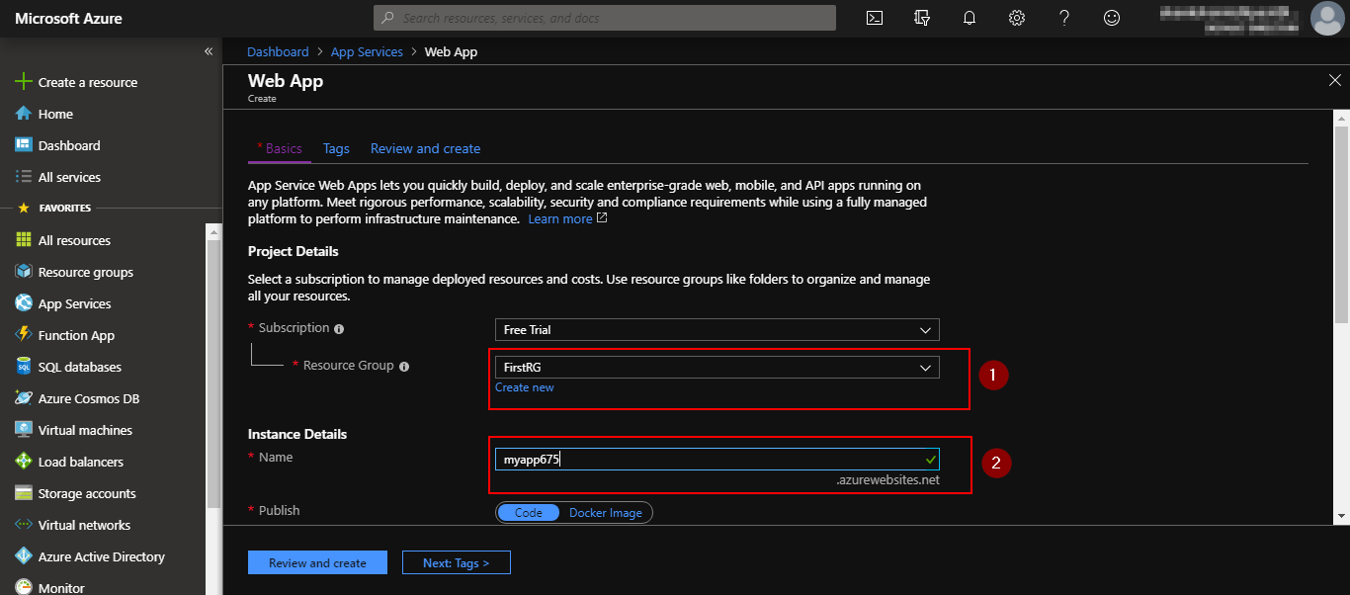

**Step 9:** Staying at the same page, scroll down. You’ll see some more fields to be filled in.

1. In the runtime stack field, select your choice of language for application development.
2. In operating system field, choose the OS of your choice.

**Note:** Some languages in runtime stack are only supported in linux OS and some only in windows and some in both. So you will need to choose the OS depending on the runtime language you have selected. We have selected PHP 7.3 and it is supported in both Linux as well as Windows.

1. In the region field, you can go ahead and choose any region or keep the default one (central US).

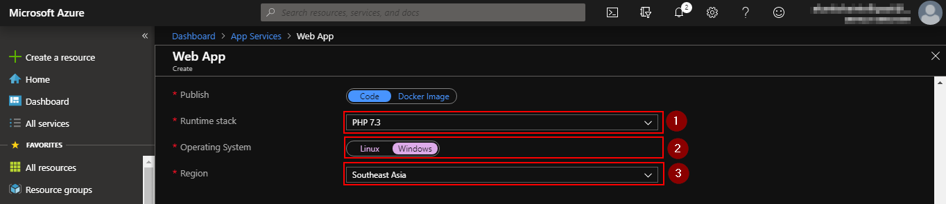

**Step 9:** Under App service plan options:

1. ForWindows plan field, click on create new and give a name to your plan. This plan defines the pricing of the resource.
2. For sku and size field, click on change size

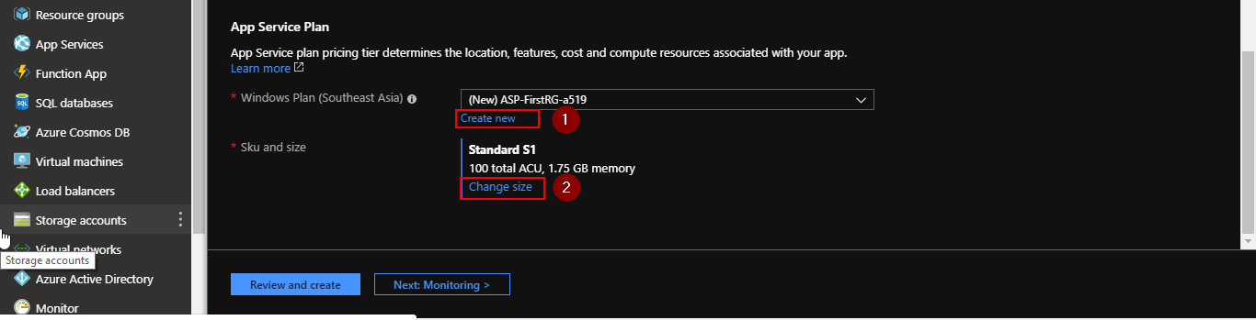

**Step 10:** After clicking on change size a window will open on right side. Click on dev/test tools. It will show recommended pricing tiers, including the one which is free. Select the free pricing tier option. As shown below and then click on apply.

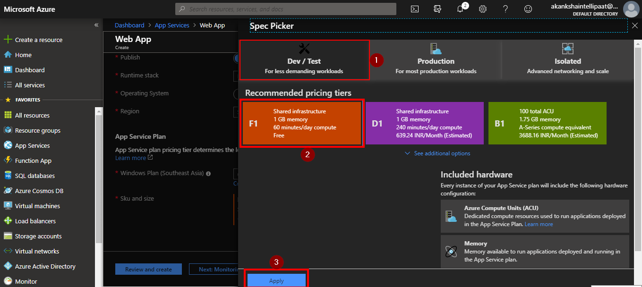

This will add the free pricing tier for your resource.

**Step 10:** Finally click on review and create and on the next page click on create.

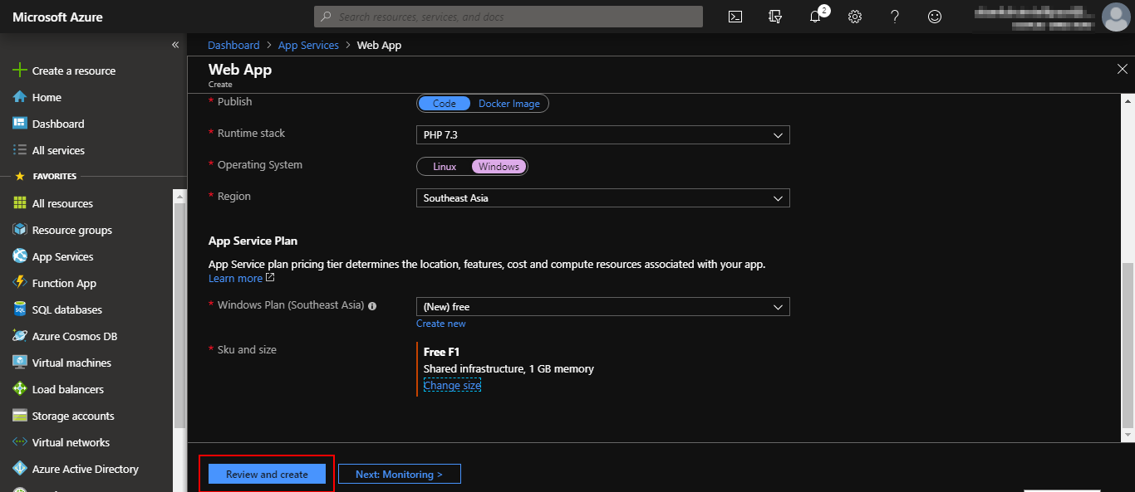

**Step 10:** After clicking on create, you'll see a notification on right top corner saying initializing deployment. After deployment is done, you will see the following page.

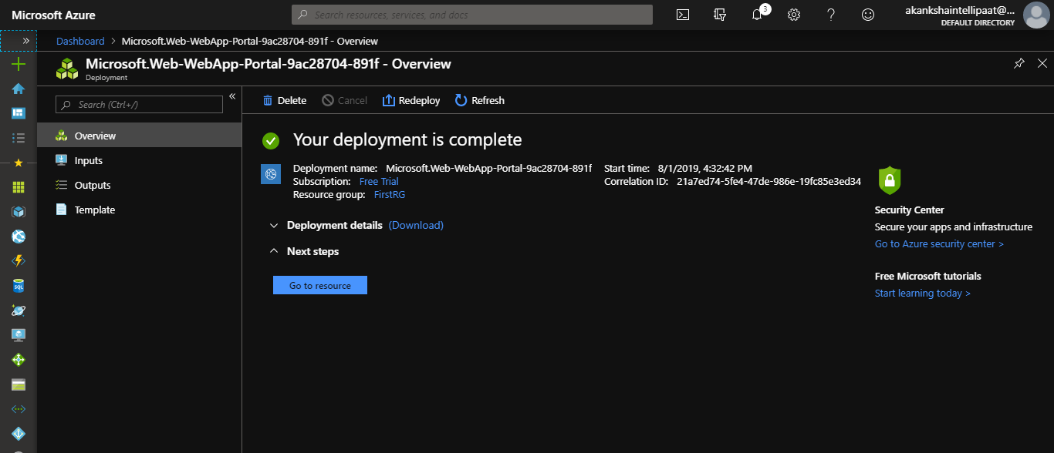

**Step 11:** Go back to the resource group section from left pane then click on your resource group. You will see your app service deployed in it.